

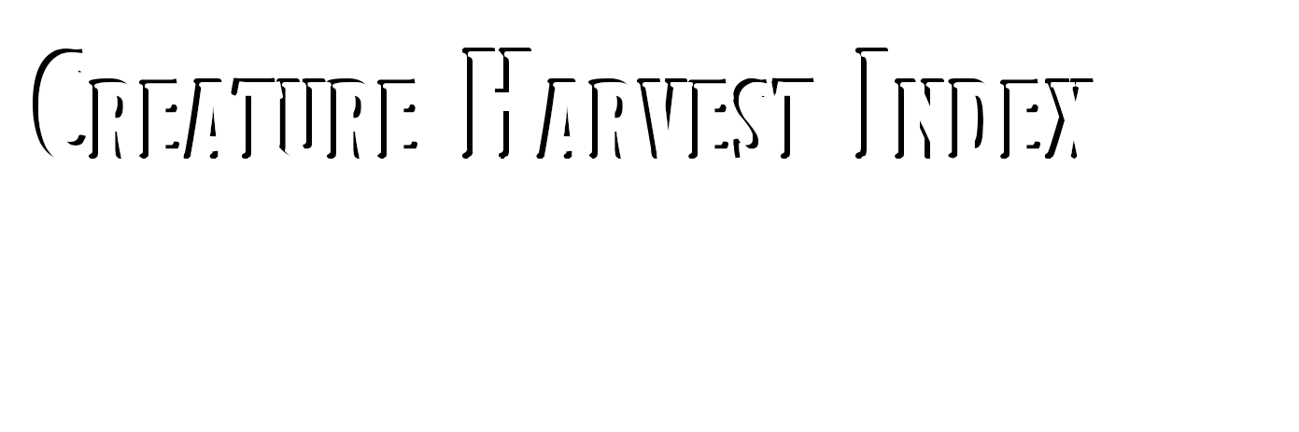

IntrodUction

D

UNGEONS & DRAGONS, D&D, Wizards of the Coast, Forgotten Realms, Ravenloft, Eberron, the dragon ampersand, Ravnica and all other Wizards of the Coast product names, and their respective logos are trademarks of Wizards of the Coast in the USA and other countries.

This work contains material that is copyright Wizards of the Coast and/or other authors. Such material is used with permission under the Community Content Agreement for Dungeon Masters Guild. Cover Artwork (c) Steve Lund.

All other original material in this work is copyright 2019 by D Larson of Paper Druid Publishing and published under the Community Content Agreement for Dungeon Masters Guild.

If yoU like this PWYW version, please see my fUll Harvest Index: VolUme I: Beasts, which inclUdes fUll skinning mechanics and harvest rUles!

Creature Harvest

Beast Possible Loot Value (GP) Use

Allosaurus Teeth

Claws Large Hide Eggs

Ankylosaurus Large Hide Scraps Bone Armor

Club Tail Eggs

2gp 3gp 8gp 750gp

6gp 12gp 3gp 250gp

Trophy Trophy

Trophy, Practical Practical

Trophy, Practical Trophy, Practical Trophy, Practical Practical

Brontosaurus Gargantuan Hide 100gp Trophy, Practical

Clawfoot Raptor Feathers Claws

Medium Hide Eggs

Deinonychus Medium Hide Claws Teeth Eggs

Hadrosaurus Large Hide Eggs

Plesiosaurus Large Hide Fin Teeth Eggs

Pteranodon Medium Hide Beak Wings Eggs

Quetzalcoatlus Huge Hide Beak Eggs

Stegosaurus Huge Hide Plates

Tail Spikes Eggs

Triceratops Huge Hide

Horns

3gp 2gp 4gp 100gp

4gp 2gp 2gp 250gp

8gp 100gp

8gp 12gp 2gp 200gp

4gp 6gp 12gp 300gp

20gp 6gp 320gp

20gp 8gp 5gp 450gp

20gp 8gp

Trophy, Practical Trophy

Trophy, Practical Practical

Trophy, Practical Trophy

Trophy Practical

Trophy, Practical Practical

Trophy, Practical Trophy, Practical Trophy

Practical

Trophy, Practical Trophy, Practical Trophy, Practical Practical

Trophy, Practical Trophy, Practical Practical

Trophy, Practical Trophy, Practical Trophy

Practical

Trophy, Practical Trophy

INDEX

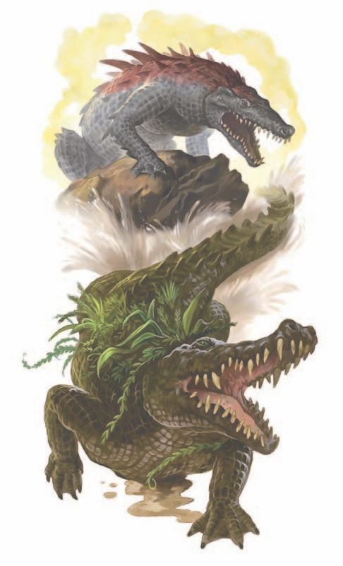

1

Eggs

500gp

Practical



Creature Harvest

Beast



Possible Loot

Velociraptor Tiny Hide

Eggs

1gp 50gp

Trophy, Practical Practical

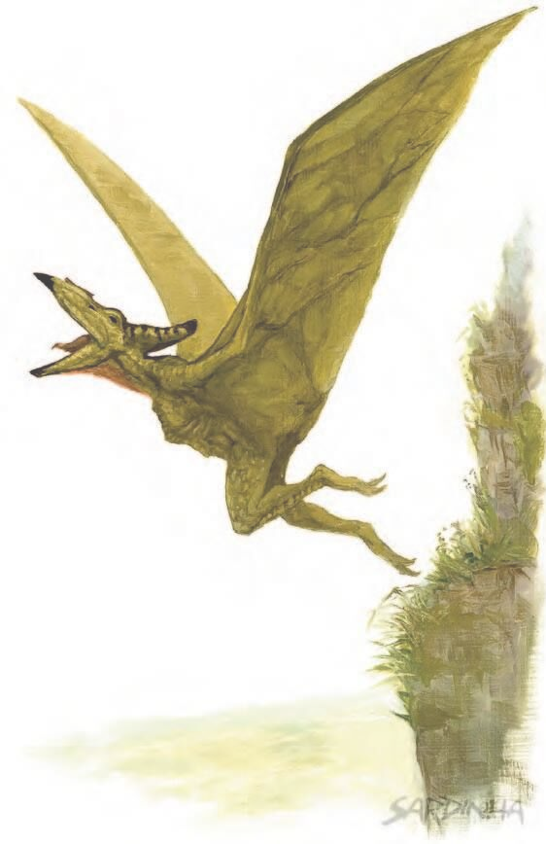



Tyrannosaurus Rex

Huge Hide Teeth Claws Eggs

20gp 3gp 4gp

1,000gp

Trophy, Practical Trophy

Trophy Practical

Value (GP)

Use



INDEX

21



An IntrodUction to Skinning

The parts I have listed here are by no means the ONLY parts you can use from a creature, but I have listed the most com- mon and easily sold pieces. Each creature will likely possess some of the following, as described by the table below:

Meat- how much, and how much a vendor may pay for it. Eggs- can be eaten or sold as future pets.

Pelts, Skins, and Hides - pelts and hides can be worked into cloaks, bags, or leathers, or sold to vendors.

Claws, Fangs, and Teeth - these parts are typically only used as trophies, but can often be sold to vendors.

Venom - certain serpents and arachnids (such as scorp- ions and spiders) possess venom glands that can be carefully extracted or bled into containers. This venom can be sold to vendors (as is illegal in many cities) or kept for personal use.



The Harvesting of Meat

Innkeepers and taverns may be interested in purchasing raw meat from players. Standard game, such as rabbits, deer, bear, etc will likely be purchased at 5cp per lb. More exotic meats, such as tiger, crocodile, and shark will be worth much more, depending on the location and the rarity of the creature whose meat you are trying to sell. I suggest 5sp per lb, with a x2 or x3 exoticism modifier per DM discretion. For more exo- tic sales, keeping a trophy to prove what the meat came from may be useful.

Meats harvested must be either salted or sold within 2 days of the kill, otherwise the meat will spoil.

PUrchase A FUll Index Today!

A full Harvest Index, for only $1, includes harvesting and skinning tables, skinner's tools details and contents, and a price table as seen above.

Thank yoU for Downloading!